Agenda Request Form
Clinch County Board of Commissioners
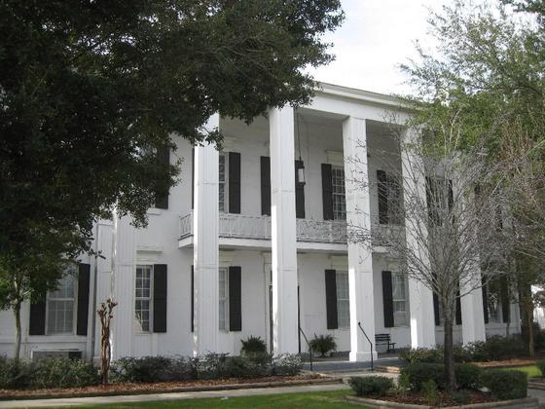
www.clinchcountyga.com

All items requiring action by the Commissioners must first be presented at a work session and must be submitted at least seven business days in advance of the requested meeting date. The following information should be provided for each item. All agenda requests must be reviewed and approved by the County Chairman.

Date of Request: ____________________________________________________

Submitted by: ____________________________________________________

Contact Information: ____________________________________________________

Item of Business: ____________________________________________________

____________________________________________________

____________________________________________________

For Meeting Date: ____________________________________________________

Name of Speaker: ____________________________________________________
Funding Information (if funding is required):

Projected Cost: $
Is this a Budgeted Expenditure? ___ Yes ___ No
If no, what is the recommended funding source:
Recommended Action:

Please attach any supporting documentation which you would like to present to the Board of Commissioners.

22 Court Square
Suite B
Homerville, Ga., 31634

Phone (912) 487-2667
Fax (912) 487-3658
E-mail clinchcounty@windstream.net

